Practical 7: Queue Implementation using Array and Linked List, with Structure Simulation
Practical Aim
To implement queue using array and linked list, and apply queue-based logic to number generation, and structure simulation problems.
Problem 1
A government office has a token counter that issues tokens to visitors. The counter can hold at most n tokens at a time. New visitors join from one end and are served from the other end in the order they arrived. If the counter is full, no new token can be issued, and if it is empty, no one can be served. Given a sequence of join and serve operations, implement this fixed-capacity token system and print the current front token after each operation. Report an error if an operation cannot be performed.
Describe how your solution tracks the front and rear of the queue. What happens to your front and rear pointers over time as join and serve operations keep happening, and does your solution handle the case where space appears to run out even though slots have been freed?
SOLUTION:
https://github.com/prathameshpandir-dev/DSA-Batch-B-SHP/tree/main/practical-7

OUTPUT:

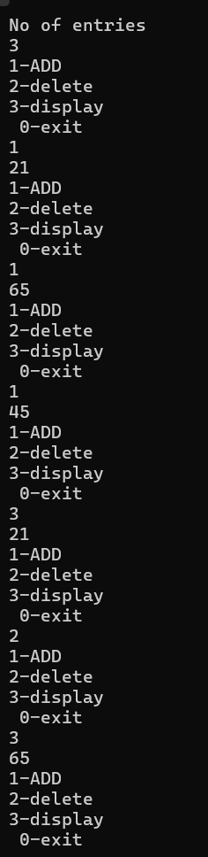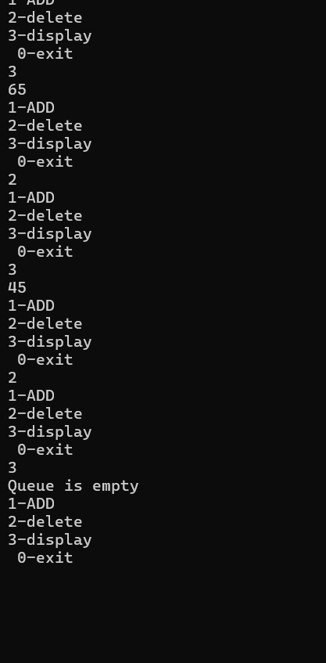

PROBLEM FACED:
The main difficulty was maintaining the front and rear positions correctly and checking both full and empty conditions before each operation.
CONCLUSION:
The fixed-capacity array queue was successfully implemented. Join and serve operations follow FIFO order and invalid operations are reported.
Problem 2
A hospital emergency ward receives patients continuously and attends to them strictly in the order they arrived, with no upper limit on how many can be waiting at once. New patients are added at the back and the doctor always attends to the patient at the front. Given a sequence of arrive and attend operations, implement this unlimited patient queue and print the current front patient after each operation.
Describe how your solution differs from Problem 1 in how it manages capacity. What happens in your solution when the attend operation is called on an empty ward with no patients waiting?
SOLUTION:
https://github.com/prathameshpandir-dev/DSA-Batch-B-SHP/tree/main/practical-7
OUTPUT:

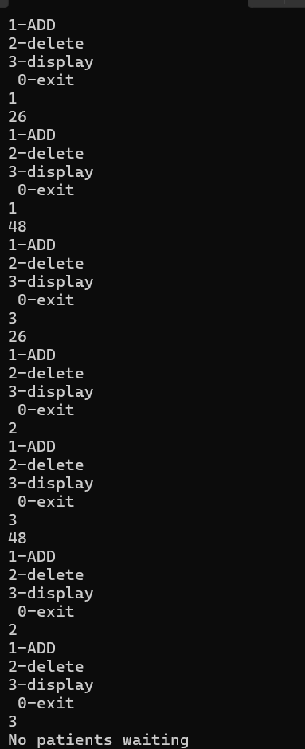

PROBLEM FACED:
The main difficulty was correctly updating both front and rear pointers when the first or last patient is removed. An empty queue must also be handled separately.
CONCLUSION:
The linked-list queue was successfully implemented with dynamic memory. Patients can be added and attended in FIFO order without a fixed array capacity.
Key questions
1. Problem 1
Answer: In a simple array queue, the front moves forward when elements are served and the rear keeps moving forward when new elements are added. Freed positions at the beginning are not reused, so the rear can reach the end even though earlier positions are empty.
2. Problem 2
Answer: If arrive operations continue much faster than attend operations, the linked list keeps creating more nodes and the queue can consume a large amount of memory. The consequence is not visible as a fixed capacity in the code because nodes are allocated dynamically.
Overall Conclusion
The practical successfully implemented queues using arrays and linked lists. The FIFO principle, overflow and underflow handling, and the difference between fixed and dynamic capacity were demonstrated.

